**EXPERIMENT NO : 06**

***Aim : Design a web page to examination registration form using the PHP.***

**PHP CODE :**

<!DOCTYPE html>

<html lang="en">

<head>

    <meta charset="UTF-8">

    <meta http-equiv="X-UA-Compatible" content="IE=edge">

    <meta name="viewport" content="width=device-width, initial-scale=1.0">

    <link rel="stylesheet" href="aditya.css">

    <title>Examination Form</title>

</head>

<body>

<?php

// define variables and set to empty values

$frollnoErr = $fnameErr = $fsubjectErr = $fyearErr = $fsemesterErr = $fphoneErr = $femailErr = $fgenderErr = $fcheckboxErr = $flocationErr =  $fcollegeErr = $fdepartmentErr = "";

$frollno = $fname = $fsubject = $fyear = $fsemester = $fphone = $femail = $fgender = $fcheckbox = $flocation =  $fcollege = $fdepartment = "";

if ($_SERVER["REQUEST_METHOD"] == "POST") {

    if (empty($_POST["frollno"])) {

        $frollnoErr = "Roll no is required";

      } else {

        $frollno = test_input($_POST["frollno"]);

        // check if name only contains letters and whitespace

        if (!preg_match("/^[0-9]*$/",$frollno)) {

          $frollnoErr = "Only numbers allowed";

        }

      }

  if (empty($_POST["fname"])) {

    $fnameErr = "Name is required";

  } else {

    $fname = test_input($_POST["fname"]);

    // check if name only contains letters and whitespace

    if (!preg_match("/^[a-zA-Z-' ]*$/",$fname)) {

      $fnameErr = "Only letters and white space allowed";

    }

  }

  if (empty($_POST["fsubject"])) {

    $fsubjectErr = "Subject is required";

  } else {

    $fsubject = test_input($_POST["fsubject"]);

    // check if name only contains letters and whitespace

    if (!preg_match("/^[a-zA-Z-' ]*$/",$fsubject)) {

      $fsubjectErr = "Only letters and white space allowed";

    }

  }

  if (empty($_POST["fyear"])) {

    $fyearErr = "year is required";

  } else {

    $fyear = test_input($_POST["fyear"]);

    // check if name only contains letters and whitespace

    if (!preg_match("/^[0-9]*$/",$fyear)) {

      $fyearErr = "Only numbers allowed";

    }

  }

  if (empty($_POST["fsemester"])) {

    $fsemesterErr = "semester is required";

  } else {

    $fsemester = test_input($_POST["fsemester"]);

    // check if name only contains letters and whitespace

    if (!preg_match("/^[0-9]*$/",$fsemester)) {

      $fsemesterErr = "Only numbers allowed";

    }

  }

  if (empty($_POST["fphone"])) {

    $fphoneErr = "year is required";

  } else {

    $fphone = test_input($_POST["fphone"]);

    // check if name only contains letters and whitespace

    if (!preg_match("/^[0-9]*$/",$fphone)) {

      $fphoneErr = "Only numbers allowed";

    }

  }

  if (empty($_POST["femail"])) {

    $femailErr = "Email is required";

  } else {

    $femail = test_input($_POST["femail"]);

    // check if e-mail address is well-formed

    if (!filter_var($femail, FILTER_VALIDATE_EMAIL)) {

      $femailErr = "Invalid email format";

    }

  }

  if (empty($_POST["fgender"])) {

    $fgenderErr = "Gender is required";

  } else {

    $fgender = test_input($_POST["fgender"]);

  }

  if (empty($_POST["fcheckbox"])) {

    $fcheckboxErr = "checkbox is required";

  } else {

    $fcheckbox = test_input($_POST["fcheckbox"]);

  }

  if (empty($_POST["flocation"])) {

    $flocation = "";

  } else {

    $flocation = test_input($_POST["flocation"]);

  }

  if (empty($_POST["fcollege"])) {

    $fcollegeErr = "college name is required";

  } else {

    $fcollege = test_input($_POST["fcollege"]);

    // check if name only contains letters and whitespace

    if (!preg_match("/^[a-zA-Z-' ]*$/",$fcollege)) {

      $fcollegeErr = "Only letters and white space allowed";

    }

  }

  if (empty($_POST["fdepartment"])) {

    $fdepartmentErr = "department name is required";

  } else {

    $fdepartment = test_input($_POST["fdepartment"]);

    // check if name only contains letters and whitespace

    if (!preg_match("/^[a-zA-Z-' ]*$/",$fdepartment)) {

      $fdepartmentErr = "Only letters and white space allowed";

    }

  }

}

function test_input($data) {

  $data = trim($data);

  $data = stripslashes($data);

  $data = htmlspecialchars($data);

  return $data;

}

?>

    <form method="post" action="<?php echo htmlspecialchars($_SERVER["PHP_SELF"]);?>">

        <div class="form">

            <div class="title-div">

                <h1> Examination Registration Form </h1>

                <p> This form is created with HTML, CSS and PHP</p>

            </div>

            <div class="roll-div" id="rollno">

                <div class="name">Roll Number : <span class="formerror">* <?php echo $frollnoErr;?></span></div>

                <div class="input-div"><input type="input" name="frollno" value="<?php echo $frollno;?>"></div>

            </div>

            <div class="name-div" id="name">

                <div class="name">Enter Your Full Name :<span class="formerror">* <?php echo $fnameErr;?></span></div>

                <div class="input-div"><input type="input" name="fname" value="<?php echo $fname;?>"></div>

            </div>

            <div class="name-div" id="subject">

                <div class="name">Enter Your Subject :<span class="formerror">* <?php echo $fsubjectErr;?></span></div>

                <div class="input-div"><input type="input" name="fsubject" value="<?php echo $fsubject;?>"></div>

            </div>

            <div class="name-div" id="year">

                <div class="name">Enter Your year :<span class="formerror">* <?php echo $fyearErr;?></span></div>

                <div class="input-div"><input type="input" name="fyear" value="<?php echo $fyear;?>"></div>

            </div>

            <div class="name-div" id="semester">

                <div class="name">Enter Your Semester :<span class="formerror">* <?php echo $fsemesterErr;?></span></div>

                <div class="input-div"><input type="input" name="fsemester" value="<?php echo $fsemester;?>"></div>

            </div>

            <div class="mobile-div" id="phone">

                <div class="name">Enter Your Phone Number :<span class="formerror">* <?php echo $fphoneErr;?></span></div>

                <div class="input-div"><input type="input" name="fphone" value="<?php echo $fphone;?>"></div>

            </div>

            <div class="gmail-div" id="email">

                <div class="name">Enter Your G-mail ID :<span class="formerror">* <?php echo $femailErr;?></span></div>

                <div class="input-div"><input type="email" name="femail" value="<?php echo $femail;?>"></div>

            </div>

            <div class="gender-div" id="gender">

                <div class="name">Gender :<span class="formerror">* <?php echo $fgenderErr;?></span>

                </div>

                <div class="radio">

                    <input type="radio" name="fgender" id="male" <?php if (isset($fgender) && $fgender=="male") echo "checked";?> value="Male">

                    <label for="male">Male</label><br>

                    <input type="radio" name="fgender" id="female" <?php if (isset($fgender) && $fgender=="female") echo "checked";?> value="Female">

                    <label for="female">Female</label><br>

                    <input type="radio" name="fgender" id="other" <?php if (isset($fgender) && $fgender=="other") echo "checked";?> value="Other">

                    <label for="other">Other</label><br><br>

                </div>

            </div>

            <div class="birth-div" id="date">

                <div class="name">Date Of Birth :<span class="formerror"></span></div>

                <div class="radio">

                    <select name="fdate" style="width:60px" required>

            <option>Date</option>

            <option>1</option>

            <option>2</option>

            <option>3</option>

            <option>4</option>

            <option>6</option>

            <option>7</option>

            <option>8</option>

            <option>9</option>

            <option>10</option>

            <option>11</option>

            <option>12</option>

            <option>13</option>

            <option>14</option>

            <option>15</option>

            <option>16</option>

            <option>17</option>

            <option>18</option>

            <option>19</option>

            <option>20</option>

            <option>21</option>

            <option>22</option>

            <option>23</option>

            <option>24</option>

            <option>25</option>

            <option>26</option>

            <option>27</option>

            <option>28</option>

            <option>29</option>

            <option>30</option>

            <option>31</option>

        </select>

                    <select name="fmonth" style="width:60px" required>

            <option>Month</option>

            <option>Jan</option>

            <option>Feb</option>

            <option>Mar</option>

            <option>Apl</option>

            <option>May</option>

            <option>Jun</option>

            <option>Jul</option>

            <option>Aug</option>

            <option>Sep</option>

            <option>Oct</option>

            <option>Nov</option>

            <option>Dec</option>

        </select>

                    <select name="fyear" style="width:60px" required>

            <option>Year.</option>

            <option>1998</option>

            <option>1999</option>

            <option>2000</option>

            <option>2001</option>

            <option>2002</option>

            <option>2003</option>

            <option>2004</option>

            <option>2005</option>

            <option>2006</option>

            <option>2007</option>

        </select><br><br>

                </div>

            </div>

            <div class="language-div" id="checks">

                <div class="name">Languages Known :<span class="formerror">* <?php echo $fcheckboxErr;?></span></div>

                <div class="radio">

                    <input type="checkbox" name="fcheckbox" <?php if (isset($fcheckbox) && $fcheckbox=="english") echo "checked";?> value="english">

                    <label>English</label><br>

                    <input type="checkbox" name="fcheckbox" <?php if (isset($fcheckbox) && $fcheckbox=="marathi") echo "checked";?> value="marathi">

                    <label>Marathi</label><br>

                    <input type="checkbox" name="fcheckbox" <?php if (isset($fcheckbox) && $fcheckbox=="hindi") echo "checked";?> value="hindi">

                    <label>Hindi</label><br><br>

                </div>

            </div>

            <div class="address-div" id="address">

                <div class="name">Address :<span class="formerror">* <?php echo $flocationErr;?></span></div>

                <div class="radio">

                    <textarea cols="50" rows="2" name="flocation"><?php echo $flocation;?></textarea><br><br>

                </div>

            </div>

            <div class="clg-div" id="college">

                <div class="name">Enter Your College name :<span class="formerror">* <?php echo $fcollegeErr;?></span></div>

                <div class="input-div"><input type="input" name="fcollege" value="<?php echo $fcollege;?>"></div>

            </div>

            <div class="class-div" id="className">

                <div class="name">Enter Your Class Name :<span class="formerror">* <?php echo $fdepartmentErr;?></span></div>

                <div class="input-div"><input type="input" name="fdepartment" value="<?php echo $fdepartment;?>"></div>

            </div>

            <div>

                <input type="submit" class="button" value="Submit">

            </div>

            <br><br><br>

            <div class="last-div">

                <p>Mr_Aditya_Nivalkar</p>

            </div>

        </div>

    </form>

?>

</body>

</html>

**CSS CODE :**

body {

    background-color: #ede7f6;

    font-family: 'Times New Roman', Times, serif;

}

.form {

    height: 1100px;

    width: 600px;

    margin: auto;

}

.title-div {

    height: 150px;

    width: 600px;

    background-color: #fdfefe;

    margin: 15px;

    border-radius: 8px;

    border-top: 8px solid #6703c4;

    padding: 25px;

}

.roll-div,

.name-div,

.clg-div,

.gmail-div,

.mobile-div,

.gender-div,

.birth-div,

.language-div,

.address-div,

.class-div {

    height: 150px;

    width: 650px;

    background-color: #fdfefe;

    margin: 15px;

    border-radius: 10px;

}

.radio {

    padding-left: 40px;

}

.name {

    padding-top: 20px;

    padding-left: 25px;

    padding-bottom: 25px;

    font-size: 15px;

}

.input-div {

    padding-top: 25px;

    padding-left: 25px;

}

.input-div input {

    width: 300px;

    border: 0;

    outline: 0;

    border-bottom: 1.5px solid #3f3939;

}

.button {

    height: 36px;

    width: 100px;

    background-color: #6703c4;

    border-radius: 5px;

    font-size: 14px;

    letter-spacing: .5px;

    font-weight: 540;

    border: none;

    padding: 10px;

    position: absolute;

    margin: 15px;

    color: white;

}

.last-div p {

    text-align: center;

    padding-top: 10px;

    color: #a2a4a6;

    font-weight: 200;

    border-bottom: 1px solid #a2a4a6;

}

.formerror {

    color: red;

    text-align: end;

}

**OUTPUT :**

**1) If we submit form without filling information then it will show validations.**

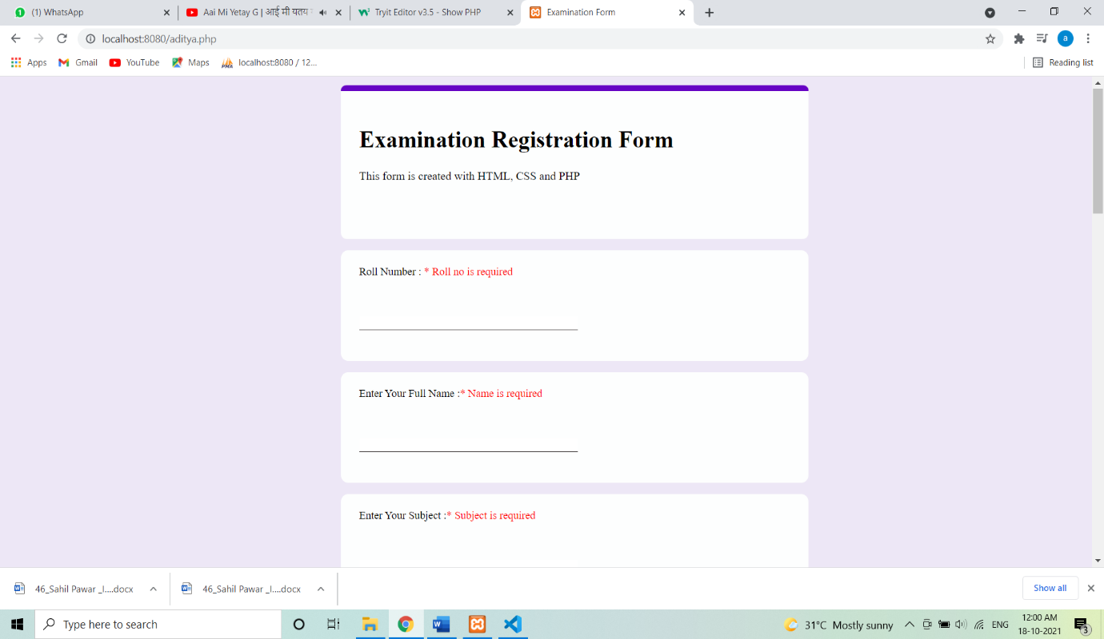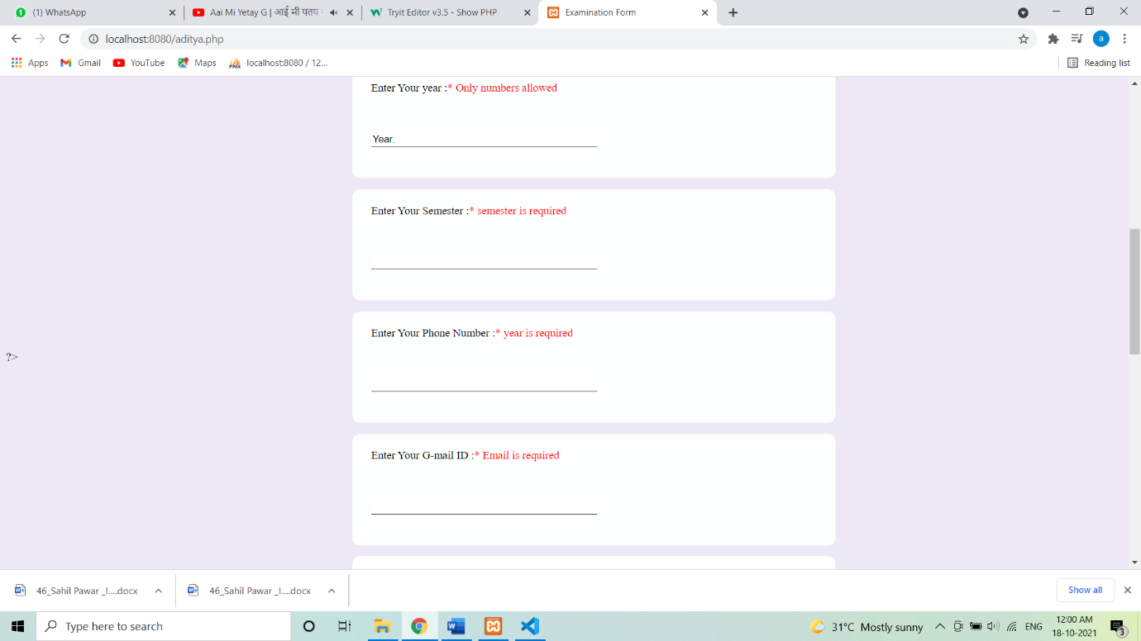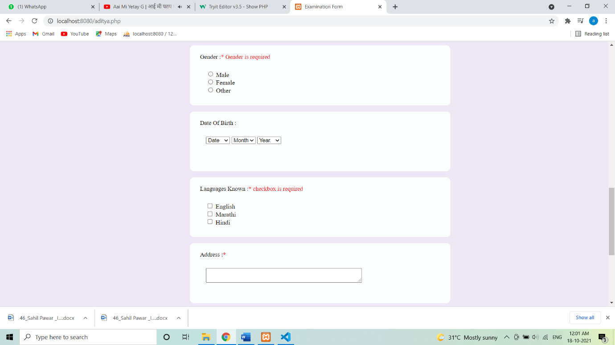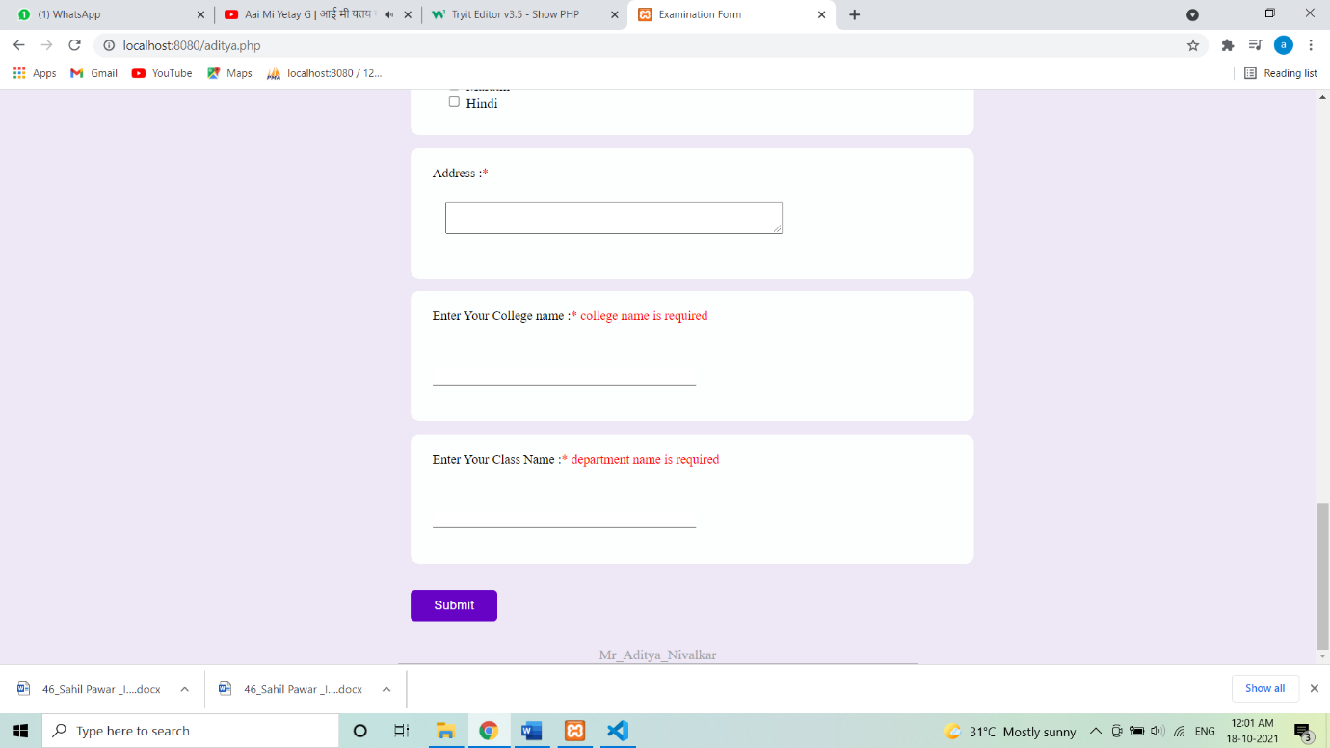

**2 ) If we fill all information correct then it will not show the validations.**

